|  |  |  |  |  |  |
| --- | --- | --- | --- | --- | --- |
| **CLINICAL PROCEDURAL DOCUMENTS**  **STANDARD OPERATING PROCEDURES (SOP)** | | | | | |
| **Document Title:** Management of infants identified to have failed hearing screening and Cytomegalovirus (CMV) pathway | | | | | |
| **This document is relevant for staff at:**  *(please indicate)* | **Luton Hospital site** | **Bedford Hospital site**  ✓ | | | **Both Hospital sites** |
| **Document Type:** | **Standard Operating Procedure** | | | | |
| **Document Author / Responsible Author(s):**  Val DeVally - SBCU Matron  Claire Adamson - Lead Nurse Neonatal  Dr Anita Mittal – Paediatric Consultant | | | | | |
| **Document Developed in consultation with / Guidance provided or issued by which body?** | | | | | |
| **Is this document new or revised / or has minor amendments? National or local guidance?**  New local document | | | | | |
| **Document Number (if applicable):** | | | **Version Number (if applicable):** | | |
| **Target Audience/Scope:**  All health care professionals involved in the care of infants within the neonatal and maternity services | | | | | |
| **Associated Trust Documents:**  Clinical Guideline: Diagnosis and Management of Congenital Cytomegalovirus East of England cCMV guideline 2017 | | | | | |
| **Approval provided by which Clinical Service Line Group Meeting:**  **Date of Approval:**  **Review Date:** | | | | | |
| **Signature of Clinical Director Lead of CSL:** | | | | **Date:** | |



Contents

Introduction 3

Aim 3

Inpatients on Neonatal Unit, Post-natal Ward or Delivery Suite 4

Babies in Community 5

Appendix 1 - NHSP referrals to neonatology for possible cCMV infection assessment 6

Appendix 2 – Hearing Screening and Congenital CMV leaflet 7

Appendix 3 - Bedford Hospital Local Implementation of cCMV Clinical guideline 9

Introduction

The 2017 European Consensus Statement for the management of cCMV1 state that “*congenital cytomegalovirus (cCMV) is the most common congenital infection in the developed world. Reported prevalence varies between cohorts but is approximately 7 per 1000 births. About half of cCMV infected babies with clinically detectable disease at birth are destined to have significant impairments in their development, and cCMV infection is implicated in approximately 25% of all children with sensorineural hearing loss (SNHL)*”. Of all children who develop cerebralpalsy, 9.6% have been shown to have had CMV viraemia on their newborn bloodspot test, indicating cCMVinfection. CMV has also been associated with a potential risk for autism. Importantly congenital CMVcan frequently cause vestibular dysfunction which can be severe (its severity is not linked to theseverity of the hearing loss) and affect a child’s motor skills, posture and stability.

There is an urgency to diagnose and assess infants with cCMV as antiviral treatment is only recommended if started in the first 4 weeks of life based on current research. For this reason, relevant investigations must be carried out by 3 weeks of life (which is the cut off for diagnosis of congenital infection), so parents and clinicians can make a timely and informed choice regarding treatment.

Aim

* All babies identified as having no clear response on the newborn hearing screening pathway should have a saliva swab sent within 3 weeks of life.
* All babies investigated for cCMV in the neonatal period (1st 28 days) should have a definitive management decision by 4 weeks of life with medication commenced as clinically indicated.

Inpatients on Neonatal Unit, Post-natal Ward or Delivery Suite

1. If the baby has Unilateral or Bilateral No Clear Response on Newborn Hearing Screen the hearing screener must make a referral to Bedford audiology for diagnostic hearing assessment, explain to parents the need for further tests and ensures the parents receive an information leaflet (Appendix 1).
2. Hearing Screener to inform Consultant covering Neonatal Unit on bleep 225.
3. Consultant or Tier 2 Doctor covering Neonatal Unit to contact the parents and explain the need for further investigations.
4. Neonatal doctors to request on ICE urine and saliva samples to be sent for CMV PCR.
5. Neonatal nurse or midwife to collect urine sample from baby (obtained from a bag or cotton wool).
6. Neonatal nurse or midwife to obtain saliva swab (taken at least one hour after breast milk, no restriction in formula fed babies).
7. Babies details to be entered on the doctors handover sheet (including hospital number) – it is the Consultant covering the Neonatal Unit’s responsibility to follow-up these results
8. If a **positive** result is reported, parents must be updated by the Consultant covering the Neonatal Unit, and an explanation given of further tests required from baby. (If a **negative** result is reported parents must be updated by the Consultant covering the Neonatal Unit, and letter sent to inform GP and audiology).
9. Bloods to be requested on ICE and taken for FBC, U+Es, LFTs, conjugated bilirubin, blood CMV DNA and CMV viral load.
10. Doctor to refer baby for MRI head with IAM views under sedation to be booked highlighting cCMV pathway (should occur by 3 weeks of age).
11. Consultant covering the Neonatal Unit to refer baby to Ophthalmology highlighting cCMV (should be seen by 3 weeks of age).
12. Baby to be booked for follow up in Baby Clinic (form to Ward Clerk on Neonatal).
13. Consultant covering the Neonatal Unitto collate results and refer to St Mary’s Paddington PID Team.
14. Consultant covering the Neonatal Unit to discuss results and management plan with parents / carers.
15. The East of England Guidelines for Diagnosis and Management of Congenital Cytomegalovirus to be followed for any treatment and further follow-ups [cCMV-EoE-guideline.pdf (eoeneonatalpccsicnetwork.nhs.uk)](https://www.eoeneonatalpccsicnetwork.nhs.uk/wp-content/uploads/2022/02/cCMV-EoE-guideline.pdf)

Babies in Community

1. If the baby has Unilateral or Bilateral No Clear Response on Newborn Hearing Screen the hearing screener must make a referral to Bedford audiology for diagnostic hearing assessment, explain to parents the need for further tests and ensures the parents receive an information leaflet (Appendix 2)
2. Hearing Screener to inform Consultant covering Neonatal Unit via Bedford Hospital switchboard on 01234 355122 asking for bleep 225.
3. Post referral letter to Neonatal Consultant of the Week c/o Bedford Neonatal Unit.
4. Babies details to be entered on the doctors handover sheet (including hospital number) – it is the Consultant covering the Neonatal Unit’s responsibility to follow-up these results.
5. Consultant covering the Neonatal Unit to refer to children’s outpatients by phone to Dect phone 6877, where an appointment will be given to the parents for the **same day as the alert received**.
6. Outpatients to inform parents of date and time of appointment and advice parents to put some cotton wool in nappy a few hours prior to the appointment in children’s outpatients.
7. Neonatal doctors to request on ICE urine and saliva samples for CMV PCR ready for attending children’s outpatient department.
8. On attending children’s outpatients, outpatient nurses to collect urine sample from baby (obtained from a bag or cotton wool) and saliva swab (taken at least one hour after breast milk, no restriction in formula fed babies).
9. Babies details to be entered on the doctors handover sheet (including hospital number) – it is the Consultant covering the Neonatal Unit’s responsibility to follow-up these results.
10. If a **positive** result is reported, parents must be updated by the Consultant or Tier 2 Doctor covering the Neonatal Unit and an explanation given of further tests required. Investigations to be requested as per East of England Diagnosis and Management oc Congenital Cytomegalovirus guideline [cCMV-EoE-guideline.pdf (eoeneonatalpccsicnetwork.nhs.uk)](https://www.eoeneonatalpccsicnetwork.nhs.uk/wp-content/uploads/2022/02/cCMV-EoE-guideline.pdf) (If a **negative** result is reported parents must be updated by the Consultant or Tier 2 Doctor covering the Neonatal Unit and letter sent to inform GP and audiology).
11. Appointment arranged for baby to attend Paediatric Blood Clinic.
12. Bloods to be requested on ICE and taken for FBC, U+Es, LFTs, conjugated bilirubin, blood CMV DNA and CMV viral load.
13. Consultant covering the Neonatl Unit to refer baby for MRI head with IAM views under sedation to be booked highlighting cCMV pathway (should occur by 3 weeks of age).
14. Doctor to refer baby to Ophthalmology highlighting cCMV (should be seen by 3 weeks of age).
15. Baby to be booked for follow up in Infant Clinic.
16. Consultant covering Neonatal Unit to collate results and refer to St Mary’s Paddington PID Team and discuss results and management plan with parents / carers.
17. The East of England Guidelines for Diagnosis and Management of Congenital Cytomegalovirus to be followed for any treatment and further follow-ups. [cCMV-EoE-guideline.pdf (eoeneonatalpccsicnetwork.nhs.uk)](https://www.eoeneonatalpccsicnetwork.nhs.uk/wp-content/uploads/2022/02/cCMV-EoE-guideline.pdf)

  
Deborah Cheshire  
Newborn Hearing Screening Programme  
Local Manager Luton & Bedfordshire  
Redgrave Children’s Centre  
Redgrave Gardens  
LU3 3QN

Tel: 01582 718187

NHSP referrals to neonatology for possible cCMV infection assessment

All screen referrals to audiology require referral to Neonatology for cCMV screening

|  |  |  |
| --- | --- | --- |
| Baby’s Name: | DOB: | NHS Number: |
| Mother’s name: | DOB: | Gestation: |
| Address: | | Telephone number: |
| Language spoken: |  | Interpreter required: Yes / No |
| Safeguarding concerns:  Yes / No |  |  |
| GP: |  |  |
| Neonatal Consultants name: |  |  |
| Date of referral: | Time of referral: |  |
| Referrer’s name: | | |

[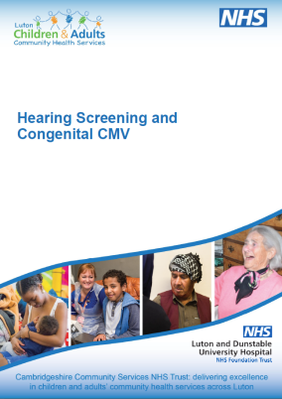](http://www.cambscommunityservices.nhs.uk/docs/default-source/leaflets---luton-paediatric-audiology/0603---hearing-screening-and-congenital-cmv.pdf?sfvrsn=2)  
Please send the completed referral to:

Consultant of the week for Neonatal Unit

Bedfordshire Hospitals NHS Foundation Trust

Bedford Hospital

Kempston Road

Bedford

MK42 9DJ

Please ensure you give the parent the information leaflet

Dr Anita Mittal

Consultant Paediatrician

Bedfordshire NHS Trust

Bedford Hospital

Kempston Road

Bedford

MK42 9DJ

Tel: 01234 355122 ext 5732

**Hearing Screening and Congenital CMV**



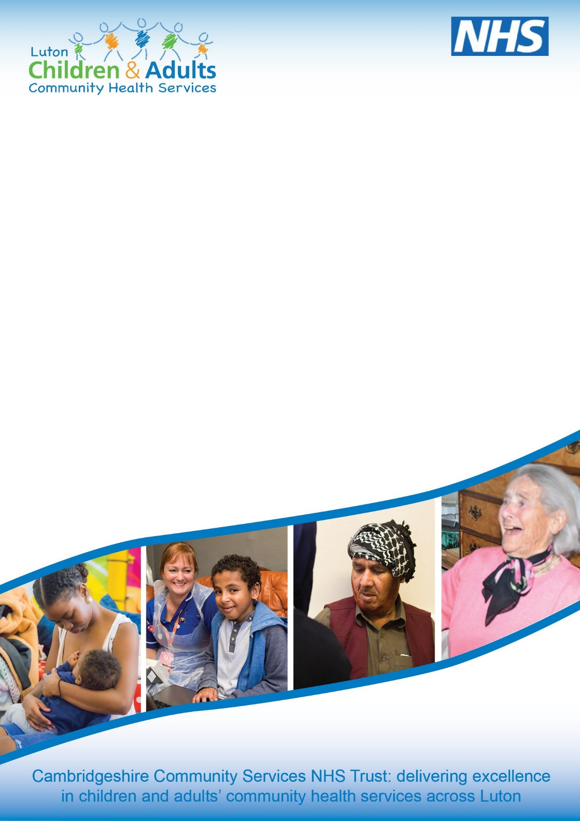



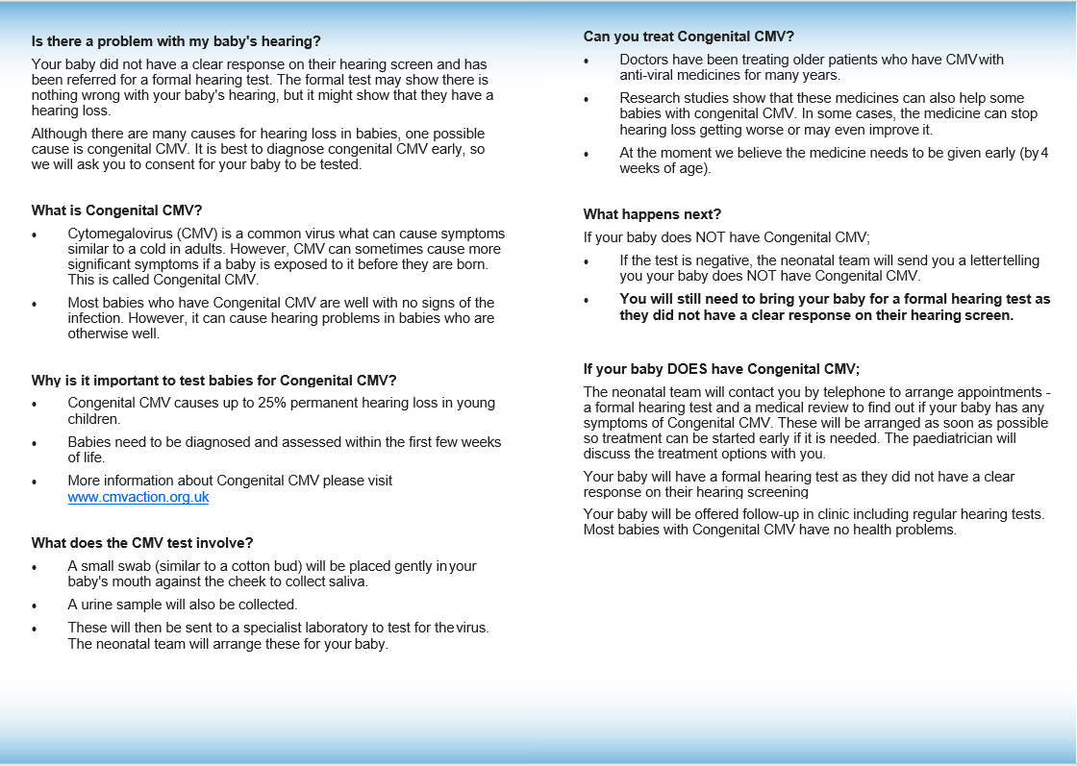

Bedford Hospital Local Implementation of cCMV Clinical guideline: This pathway is to be used in conjunction with the East of England network guideline entitled “**Clinical Guideline: Diagnosis and Management of Congenital Cytomegalovirus”** version 13**.**

Baby presents to neonatologist with symptoms/ signs suggestive of cCMV

Baby has No Clear Response on NHSP – screener explains referral to Bedford audiology for diagnostic hearing assessment and referral to neonatal team

Screener contacts neonatal Consultant on bleep 225, who arranges to see baby on the Paediatric Outpatient Department on the **same day**

This will include babies on neonatal unit, orchard ward, delivery suite, community Audiology clinics (For babies discharged early or born at home)

Babies already discharged or born in the community – within 24 hours (liaise with PNW)

Positive result – an alert will be raised via the NICU daily actionable list (Handover List)

Urine and saliva samples sent for CMV PCR (Take saliva sample at least one hour after breast milk. No restriction in formula-fed babies). To enter the details on the handover list to chase the results.

Email sent to CMV champion with hospital number and date of sending specimens.

Bedford audiology refer to community audiology for VRAs and sends results to CMV champion who will cancel clinic views if ABR results are normal

Neonatal Consultant /CMV champion will write a letter to parents with copies to GP and audiology

Neonatal Consultant/ SpR explains need for investigations and gives parent an information leaflet and print the request forms.

Follow up for “treatment given” and “no treatment given” babies with CMV champion as per East of England guideline with audiology every 3 months until 1 year and then 6 monthly and developmental assessment at 1 year with St. Marys’ and 2 year with community paediatrics.

Neonatal Consultant to collate results and refers to St. Marys’ PID team.

Shares results and management plan with family via telephone/ face to face and starts treatment if indicated by 4 weeks of age

Neonatal consultant covering neonatal unit arranges to see baby in paediatric OPD within 72 hours of alert

Explanation for further tests given along with ‘CMV – What to expect’ leaflet

FBC, U+Es, LFTs, conjugated bilirubin, blood CMV DNA, CMV viral load taken. MRI head with IAM views under sedation booked highlighting cCMV pathway (should occur by 3 weeks of age)

Refer to Ophthalmology by letter (should be seen by 3 weeks of age)

Refer to CMV champion by letter and email to be seen in infant clinic

Negative result