FOI 3122

Date 25/07/2024

Dear Requester,

Thank you for your Freedom of Information request. Please note, this is a cross-site response for Bedford site and Luton site.

You asked:

1. Do you collect data on call volumes? If so, please would you provide call volume data in whatever format requires least work for you, ideally for the year up to the date of this letter, but if you do not have recent information, for the last contiguous year period you have available.

Please see call data attached.

1. Please provide details of any policies regarding staffing levels in your main switchboard (e.g. a copy of a written policy or, in the absence of such a written policy, relevant meeting minutes or communications).

For the L&D site, we have adequate staffing to deal with calls on a 2 weekly rota.

For the Bedford site, we work continiously and have adequate staffing levels in Telecoms. We work on a 6 weekly rota, shift patterns are as follows:

06:00 – 14:00

08:00 – 16:00

10:00 -18:00

12:00 – 20:00

14:00 – 22:00

Night – 22:0 – 06:00

1. Do you use any automated navigation system to manage your calls? If so, please provide a description of how this system works (e.g. in flowchart format), and any documents relating to how the structure of this system was decided.

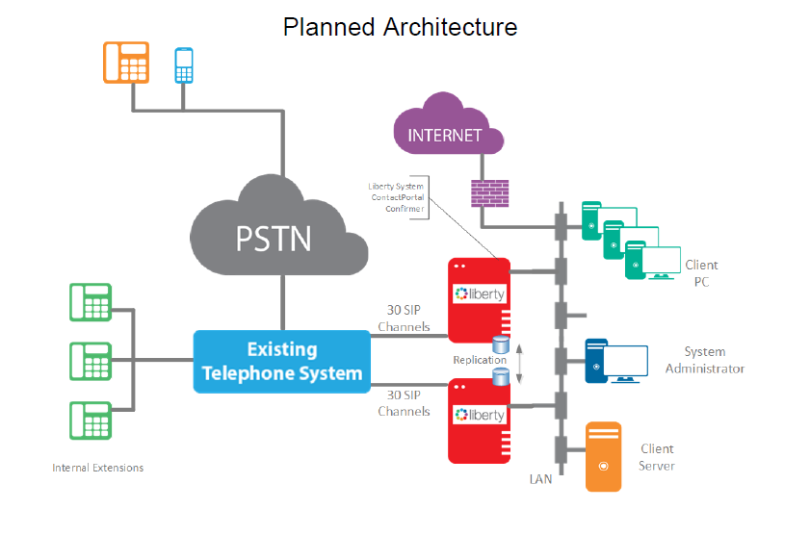

1. Please provide details of any policies for deciding the presence/content of recorded messages that are heard by callers to your switchboard, and of procedures for reviewing such messages/their content.

We do not record messages

1. Please provide details (track name) of any hold music provided to callers to your switchboard.

No MOH

1. Please provide details of any policies for deciding what hold music is provided to callers to your switchboard.

N/A

1. Do you collect data on times until callers are answered? If so, please would you provide these data in whatever format requires least work for you, ideally for the year up to the date of this letter, but if you do not have recent information, for the last contiguous year period you have available.

|  |
| --- |
| Luton |
| cid:image003.png@01DAD2F2.6E1CC9F0 |

|  |
| --- |
| Bedford |
| cid:image004.png@01DAD2F2.6E1CC9F0 |

1. Does your switchboard have any procedure for dealing with any calls that go unanswered for a very long time, such as dropping the call after a period of time or redirecting to a different operator? If so, please provide details of that procedure.

Calls that are answered by the operators get put through to the person/extension that they request - calls that are not answered come back to Switchboard automatically. Operators will continue to try and get them through including any other possible numbers on the directory.

If there is no joy in getting them through the operator will give the caller the option to either be given the extension numbers to try and call themselves directly later on or if callers are not happy, we can transfer them to PALS where they can raise a complaint.

This information is provided for your personal use and is the property of Bedfordshire Hospitals NHS Trust and subject to any existing Intellectual Property and Database Rights. Any commercial application or use of this information may be subject to the provisions of the Re-use of Public Sector Information Regulations 2015 (RPSI). This means that if you wish to re-use the information provided for commercial purposes for any reason you must ask the Trust for permission to do so.

Please note that the Trust has a formal internal review and complaints process which is managed by the Information Governance Manager/Data Protection Officer. Should you have any concerns with our response, you can make a formal request for an internal review. Requests for internal review should be submitted within three months of the date of receipt of the response to your original letter, and should be addressed to: dataprotectionofficer@ldh.nhs.uk. This option is available to you for up to three calendar months from the date your response was issued.

If you are not satisfied with the Trust review under the Freedom of Information Act 2000 you may apply directly to the Information Commissioners Officer (ICO) for a review of your appeal decision. The ICO can be contacted at: ICO, Wycliffe House, Water Lane, Wilmslow, Cheshire, SK9 5AF www.ico.org.uk

Yours sincerely,

*FOI Officer*

Bedfordshire Hospitals NHS Foundation Trust