

|  |
| --- |
| **MY HEALTH AND ME** |

This information will help my carers and family and NHS staff who support me to have a better understanding of my needs.

**It is my property and should always be returned to me. If it gets lost, please speak to the Health Equalities Service.**

|  |
| --- |
| **NHS Number:**  **Hospital Number:** |

|  |
| --- |
| My Name Is  (Include a photo if you want to) |
|  |
| I like to be called: |
|  |

|  |  |  |  |  |  |  |  |  |  |  |  |  |  |  |  |  |  |  |
| --- | --- | --- | --- | --- | --- | --- | --- | --- | --- | --- | --- | --- | --- | --- | --- | --- | --- | --- |
| **Mental Capacity Act 2005**  **I have a learning disability. Please do not assume that I cannot make my own decisions.**  **If I am assessed as lacking the capacity to consent to my treatment, the following people must be involved in any decisions made in my best interests.**   |  |  |  | | --- | --- | --- | | Name | Next of Kin | Contact Details | |  |  |  | |  |  |  | |  |  |  | |  |  |  | |  |  |  | |
| Important Information about me |

c

|  |  |
| --- | --- |
|  | I want people to refer to me as: Male (he/ his) Female (she/ her) Non binary (there/ them) |
|  | Date of Birth: |
|  | Address and telephone number:  I live alone/ I live with family/ I live with carers/ In supported living or residential care |
|  | GP Details: |
|  | People involved in my health care: |
|  | Family/ Next of Kin Contact/ Carer or advocate details.  Does anyone in my family have a Power of Attorney? |
|  | Religion and Ethnicity/ Cultural Needs: |
| Things you must know about me | |

|  |  |
| --- | --- |
|  | Communication: how to communicate with me/ how I tell you I am in pain. |

|  |
| --- |
| My mental health and emotional well-being and how to communicate with me |

|  |  |
| --- | --- |
|  | What things I like (what makes me happy) |
|  | What things I don’t like (what makes me sad) |
|  | What makes me angry? |
|  | What can people to do to make me feel better? |

|  |
| --- |
| Important things you must know about me: |

Medical History

|  |  |
| --- | --- |
|  | Diagnosis :( medical conditions) and treatment plans- this can include the things you need help with when you are in hospital. |
|  | Allergies: |

Important things to know about my medication and how I take them

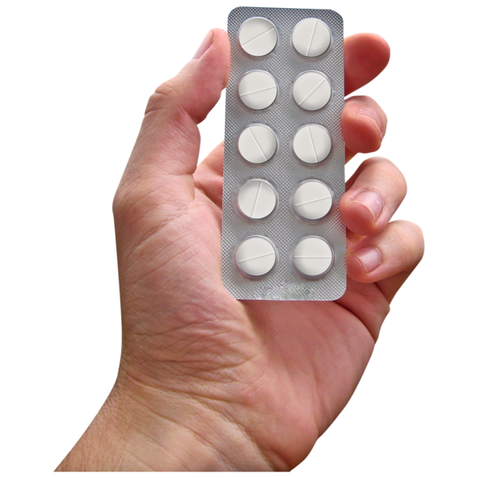

|  |  |  |  |  |
| --- | --- | --- | --- | --- |
| **Medication and what it is for** | **Dose and how often I take it** | **How I take this** | **When it should next be reviewed** | |
|  |  |  |  | |
|  |  |  |  | |
|  |  |  |  | |
|  |  |  |  | |
|  |  |  |  | |
|  |  |  |  | |
|  |  |  |  | |
|  |  |  |  | |
|  |  |  |  | |
|  |  |  |  | |
|  |  |  |  | |
|  |  |  |  | |
|  |  |  |  | |
| My care and support needs- what I need you to help me with | | | |

|  |  |
| --- | --- |
|  | Moving around/ mobility: |
|  | Support with washing and dressing: |
|  | Seeing/ Hearing: |
|  | How I eat food (cut up/ soft/pureed): |
|  | How I drink (thickened fluids) |
|  | How I stay safe: |
|  | How I use the toilet: |
|  | How I sleep (what help I need) |

|  |
| --- |
| **Reasonable adjustments- things I need you to do to help me have a better experience** |

|  |  |
| --- | --- |
|  |  |
| **When I am in hospital I need you to help me by doing these things?** | |

|  |  |
| --- | --- |
|  |  |

**Diary of Health Appointments**

|  |  |  |  |
| --- | --- | --- | --- |
| Date/ Time | Reason for attending | Outcome | Action?/ Action outcome |
|  |  |  |  |
|  |  |  |  |
|  |  |  |  |
|  |  |  |  |
|  |  |  |  |
|  |  |  |  |
|  |  |  |  |
|  |  |  |  |
|  |  |  |  |
|  |  |  |  |
|  |  |  |  |
|  |  |  |  |
|  |  |  |  |
|  |  |  |  |
|  |  |  |  |
|  |  |  |  |
|  |  |  |  |
|  |  |  |  |
|  |  |  |  |
| Date/ Time | Reason for attending | Outcome | Action?/ Action outcome |
|  |  |  |  |
|  |  |  |  |
|  |  |  |  |
|  |  |  |  |
|  |  |  |  |
|  |  |  |  |
|  |  |  |  |
|  |  |  |  |
|  |  |  |  |
|  |  |  |  |
|  |  |  |  |
|  |  |  |  |
|  |  |  |  |
|  |  |  |  |
|  |  |  |  |
|  |  |  |  |
|  |  |  |  |
|  |  |  |  |
|  |  |  |  |

**Document completed on:**